**Team Inventory**

LabRats

Project Sponsors: Dr. Terry E. Baxter & Michael Kelley

Team Mentor: Jun Rao

Julian Bell

Remy Brandriff

Maria Granroth

24 September 2018



**Overview**

The purpose of this team inventory document is to briefly introduce the members of our team. The following pages briefly outline the training, skills, and relevant experience of each team member.

**Julian Bell**

Major: Computer Science

Hometown: Phoenix, AZ

Education

* Horizon High School (Scottsdale, AZ)
  + 3.6 unweighted GPA
* Northern Arizona University
  + CS345: Principles of Database Systems
  + CS386: Software Engineering
  + *Minor in Mathematics*

Work Experience

* No official work experience in the field of CS (jobs/internships/etc), but have pursued numerous small projects with friends and individually that have strengthened skills
  + Worked on website drafts for family members’ businesses
  + Game development using Unity with varying project completeness levels
* Worked as a teaching assistant at Northern Arizona University for a MAT136 course (Calculus I) during the Fall 2016 semester
  + Strengthened social and communication skills
  + Learned how to meet quick, frequent deadlines while completing all work

Skills

* 5 years Java/Android development: from personal projects and CS136, CS249, CS399 at NAU
* 4 years Python: from CS126, CS460, and various others at NAU and from initially learning programming
* 4 years Web development (HTML, CSS, etc): from CS212 at NAU and personal projects
* 3 years C#: mainly through Unity, a game development suite
* 1 year SQL: developed rudimentary skills in SQL from CS345 at NAU
* Limited classroom experience in C, Scheme, and finite automata theory

Other interests

* Involved in music production and DJing as a hobby for 7 years; particularly intrigued by generative/algorithmic music in music genres such as techno
* Machine learning
* Game design (particuarly in specific fields of programming, audio engineering)

**Remy Brandriff**

Major: Applied Computer Science

Hometown: Tucson, AZ

Education

* Marana High School
  + 3.5 weighted GPA
* Northern Arizona University
  + CS345: Principles of Database Systems
  + CS399: Mobile Application Development
  + CS460: Computer Networks
  + CS470: Intro to Artificial Intelligence
  + *Minor in Biology*

Work Experience

* Technical support in NAU’s Housing and Residence Life department during summer 2018, working with faculty to improve how we implement the StarRez software across 16 residence halls and the central office, primarily using SQL and database management

Skills

* 8 years in Java, C++, and Android development: I started development in these languages first year of high school and have used them consistently since
* 4 years in Python: Between classes and personal use, I’ve been using Python on a frequent basis for various purposes, including networking and applications
* 1 year in SQL/MySQL: I have used SQL and MySQL off and on for about a year, between classes and my summer job
* Limited classroom experience in C, Prolog, and web development (HTML5, CSS, PHP, JavaScript, and XML)

Other interests

* I write sci-fi novels and short stories
* I have six houseplants taking over my apartment
* I’ve worked in Housing and Residence Life for four years

**Maria Granroth**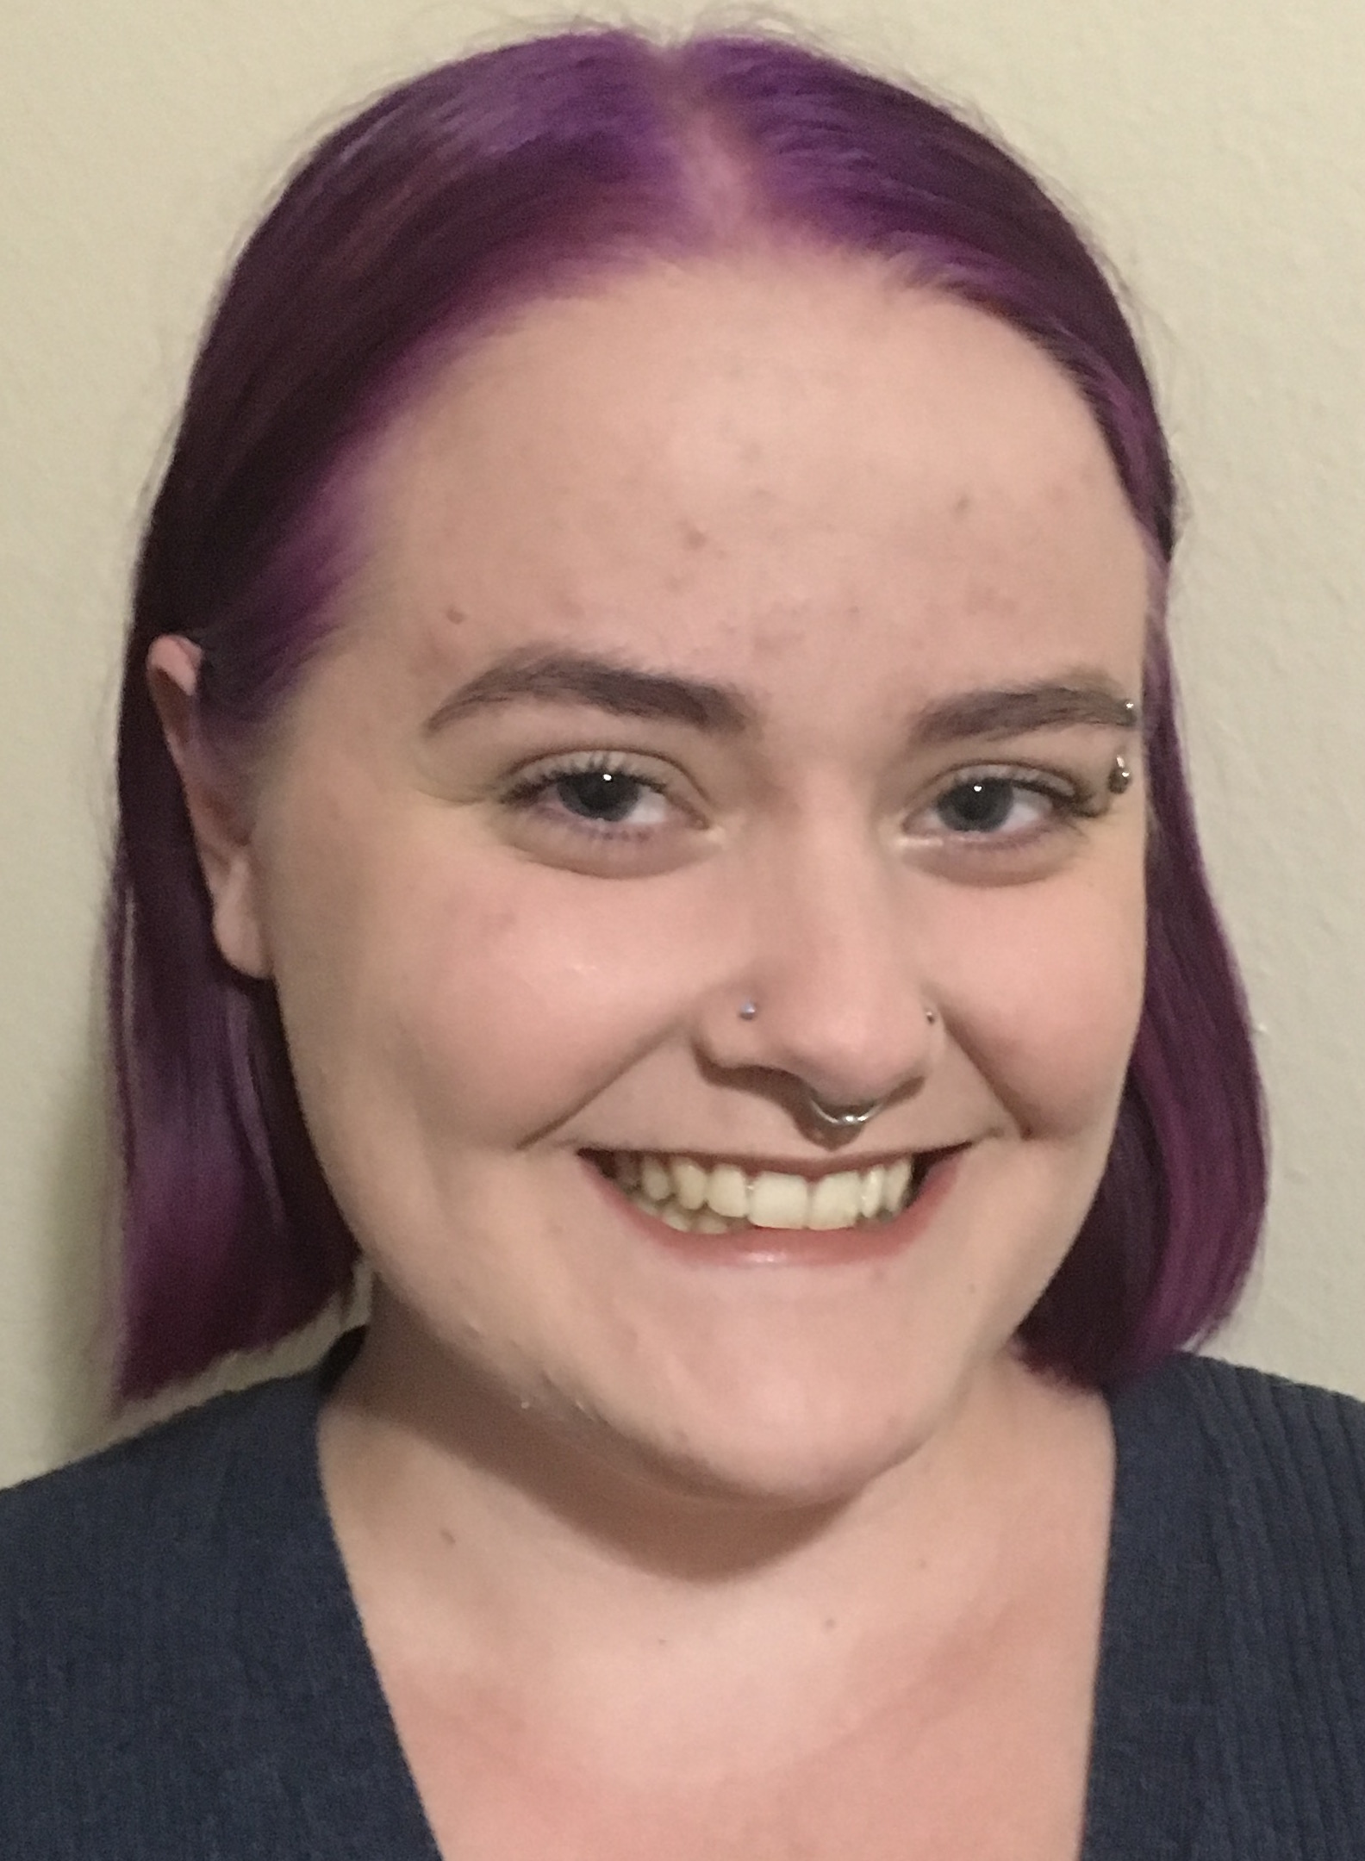

Major: Computer Science

Hometown: Gilbert, AZ

Education

* Gilbert High School
  + 4.6 weighted GPA
* Northern Arizona University
  + CS386: Software Engineering
  + CS499: Research Methods for Software Engineering

Work Experience

* Summer 2016 undergraduate researcher with NAU Chemistry and Biochemistry. Studied how ionic liquids affect cell membranes using molecular dynamics. I scripted these simulations in Python to improve time, space, and workload efficiency.

Skills

* 3 years in Java: I have been learning and using Java through college courses
* 1 year in Python: I actively used Python for about a year through classes and my undergraduate research
* Used Django for my CS386 semester project
* Limited classroom experience in C and basic Web programming

Other interests

* I have three spoiled cats
* I enjoy simulation and puzzle video games
* A life goal of mine is to have a self-sufficient farm